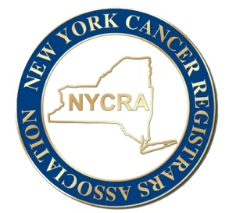

NYCRA

Job Listing Request Form

NYCRA will post job opportunities for a fee of $100.00. Posts will be made after payment and form are received (please note these are separate steps).

Job opportunities will be emailed (one time) to current membership, posted on our social media outlet (FB/IG) and posted on the website for 3 months, unless contacted by posting company for removal of posting prior to the 3-month expiration.

Please complete the following form and return via email to [newyorkcancerregistrarsassoc@gmail.com](mailto:newyorkcancerregistrarsassoc@gmail.com)

Payment can be made online at <https://newyorkcancerrgs.securepayments.cardpointe.com/pay> (Invoice & customer number are left blank) or via check made payable to NYCRA mailed to: Alesia Desgrosiellier, RHIT, ODS-C

15 Birch Lane

Halfmoon, NY 12065

**Job Title:**

**Company Name:**

**Introduction:**

**Job Description:**

**Required Qualifications:**

**Preferred Qualifications:**

**Education Qualifications:**

**Compensation/Benefits:**

**Instructions for Resume Submission:**