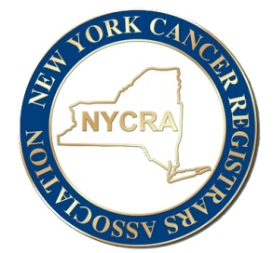
NYCRA
Job Listing Request Form

NYCRA will post job opportunities for a fee of $100.00. Posts will be made after payment and forms are received.
Job opportunities will be emailed (one time) to current membership, one post on our social media outlet (FB/IG) and posted on the website for 3 months, unless contacted by posting company for removal of posting prior to the 3-month expiration.
Please complete the following form and return via email to newyorkcancerregistrarsassoc@gmail.com
Payment via check (made payable to NYCRA) or online @ https://newyorkcancerrgs.securepayments.cardpointe.com/pay (Invoice & customer number are left blank)
Mailed to: Tarah Hoogkamp
63 Vosburgh Trailer Park
Mechanicville NY 12118.
Job Title:

Company Name:

Introduction:

Job Description:

Required Qualifications:

Preferred Qualifications:

Education Qualifications:

Compensation/Benefits:

Instructions for Resume Submission:

