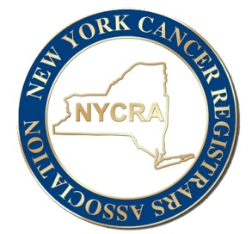

NYCRA

Organization Advertisement Application

NYCRA offers advertisement opportunities for organizations on our website for a fee of $350.00 per 3 month period. NYCRA will place the company logo on our home page that will be hyperlinked to the organization’s website or area they would like to advertise.

Advertisement will not be placed on our website until ***both*** application and payment are received (please note these are separate steps).

Please complete the following and return via email to [newyorkcancerregistrarsassoc@gmail.com](mailto:newyorkcancerregistrarsassoc@gmail.com)

Payment can be made online at [https://swipesimple.com/links/lnk_44ef35a2d33bbbb4239239ff7f0556dc](https://swipesimple.com/links/lnk_44ef35a2d33bbbb4239239ff7f0556dcor) (there is a 3.5% service charge added when paying online) or via check made payable to NYCRA mailed to:

Alesia Desgrosiellier, RHIT, ODS-C

15 Birch Lane

Halfmoon, NY 12065

**Organization:**

**Hyperlink/ website:**

**Contact Name:**

**Contact Email:**